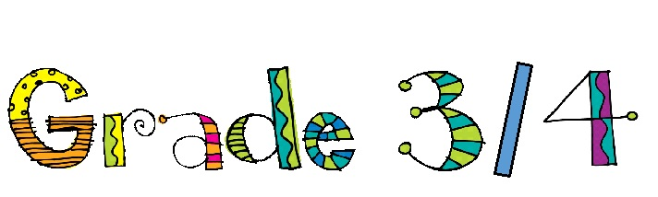
In the fall, you will be in Ms. Gruhn’s Grade 3/4 class.
You will need the following supplies:
4 Notebooks (No Coils) (32 page)
36 Pencils (HB)
1 Ruler (wooden or unbreakable)
1 Pair of scissors
6 Large glue sticks or 10 small glue sticks
1 Elmers white or clear glue
1 Package of pencil crayons (sharpened)
1 Package of washable markers
1 Sharpie
3 Whiteboard markers
1 Whiteboard Eraser
1 Whiteboard
10 Erasers
1 Pencil sharpener
1 Blue pen
3 Highlighters – one of which must be yellow
6 Duo Tangs 1 of each color – red, orange, yellow, green, blue, purple
1 300-500 pg. pkg white unlined paper
1 Pair of gym shoes – non-marking
1 Reusable water bottle
2 Boxes of Kleenex
1 Small flashlight with an extra set of batteries
1 Box of disposable spoons
1 Box of disposable forks
1 Box of Ziplock sandwich bags – GIRLS ONLY
1 Box of Ziplock large freezer bags – BOYS ONLY
1 Set of headphones for computers (labeled and in a Ziploc bag)
1 Only 1 container for pencil crayons, pencils, scissors and glue
1 Pair of sport eyewear in a labeled bag (if you do not wear prescription glasses)
1 Set of flashcards for each: multiplication, division, addition, subtraction

*GRADE 3 ONLY:
1 Package of 100 craft sticks

*GRADE 4 ONLY:
1 Calculator

** Please label everything. Thank you! **

