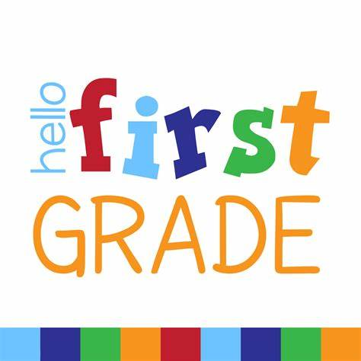

In the fall you will be in Mrs. Becotte’s Grade 1A class. Here is a list of the things you will need. Please label all items.



1 Large backpack
24 HB Pencils (Dixon or Ticonderoga), SHARPENED
5 White erasers
5 Large glue sticks
1 Pair of good quality scissors
1 Bottle of white glue
1 Package of Crayola wax crayons
1 Package of washable markers
3 Highlighters (chisel tip, any color)
8 Whiteboard markers (Broad or Chisel tip)
1 Whiteboard (at least 8 ½”x 11”) ruled/lined on one side—white on other side
* These can be found at our local pharmacy or at any Staples store.
2 Plastic pencil boxes to hold pencils, scissors, glue etc.
3 Hilroy - 1/2 dotted interlined & 1/2 blank notebook (green cover, #12155)
4 Duo tangs— 1 blue, 1 red, 1 yellow, 1 green
1 Portfolio – Twin Pocket style with prongs
3 Boxes of tissues/Kleenex
1 Pair of gym shoes—non-marking
1 Set of headphones (labeled & placed in large Ziploc bag) No earbuds please.
1 Paint Shirt (an old t-shirt works best)
1 Water bottle for drinking (we have water refill station)
1 Set of extra clothing (Labeled & placed into a bag - Including: shirt, pants, underwear, socks)
2 Packs of disposable spoons
1 Container of playdough (any color)
1 Regular exercise notebook, 32 pages (any color)

