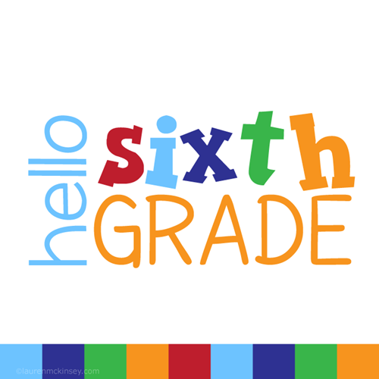

In the fall your child will be in Mrs. Harding’s Grade 6A class! For the 2025/2026 school year, your child will require the following supplies:

- Pencil case - LABELED
60 Pencils (sharpened) – These seem to go missing quickly so extras don’t hurt.
6 Erasers
1 Package of pencil crayons (sharpened)
1 Package of Markers - LABELED
2 Black sharpies
2 Black fine tip sharpies
5 Highlighters (different colours)
2 Red/green or purple pens
5 Blue or black pens
1 Pair of scissors - LABELED
1 Ruler
3 Glue sticks
1 Bottle of white glue
6 Hilroy notebooks (no coils, 32 pages)
8 Duo tangs - (Blue, Red, Green, Yellow, White, Orange, and 2 of your own choice) - please do not label – we will label them on the first day of school all in the same spot.
1 Package of loose-leaf graph paper
1 Packages of loose-leaf lined paper
1 Package of post-it notes
2 Whiteboard Markers - LABELED
3 Large boxes of Kleenex
1 Pair of gym shoes (non-marking) - LABELED
1 Set of headphones - LABELED
1 Pair of safety eyewear for gym - LABELED
2 Bags/boxes of plastic disposable forks for classroom use.
2 Bags/boxes of plastic disposable spoons for classroom use.
3 Large Ziplock Bags
1 Reusable water bottle
1 Protractor
1 Pack of recipe note cards
- Pack of Solo Cups

***Please do not send your child to school with a 3 ring binder***

