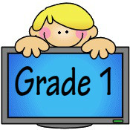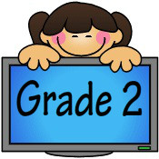
In the fall you will be in Ms. Guttormson’s Grade 1/2B class. Here is a list of the things you will need. Please label items with an *.
- Large book bag*
2 Pencil boxes (to hold pencils, scissors, glue etc)*
24 HB Pencils (Dixon or Ticondergoga)
6 White erasers
5 Large glue sticks*
1 Pair of good quality scissors*
1 Bottle of white glue
1 24 Pack of Crayola pencil crayons*
1 24 Pack of Crayola wax crayons*
1 Pack of washable markers*
1 Package of highlighters (chisel tip, any color)*
2 Black Sharpie markers (fine tip)
2 Clear tape (ex: Scotch) **For Makerspace – see reverse**
8 Whiteboard markers (Broad or Chisel tip)*
1 Whiteboard (at least 8 ½”x 11”) ruled/lined on one side—white on other side*
2 Hilroy notebooks - 1/2 dotted interlined (green cover, #12155) (Grade 1s only)
2 Hilroy notebooks – 1/2 page yellow cover (#12150 72pgs) (Grade 2s only)
4 Duo tangs— 1 blue, 1 red, 1 yellow, 1 green
2 Portfolios – Twin Pocket style with prongs
1 1/2” 3-ringed white binder
1 Package of binder tabs
1 Pair of gym shoes—non-marking*
1 Set of headphones (labeled & placed in large Ziploc bag) No earbuds please.
1 Art Smock/Paint Shirt (can be a large shirt)
1 Reuseable water bottle
1 Set of extra clothing (Labeled & placed into a bag - Including: shirt, pants, underwear, socks)
1 Box of tissues
1 Box of disposable forks or spoons
1 Box of large or medium Ziplock bags

