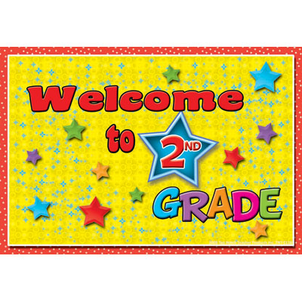
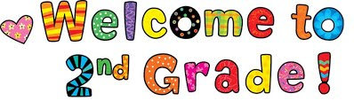
In the fall you will be in Mrs. Kraft & Mrs. Rhinehart’s Grade 2A classroom. You will need to bring the following supplies:
6 Erasers – DO NOT LABEL
20-24 Pencils (good quality) – please sharpen and DO NOT LABEL
2 Small storage kits (for pencils, erasers, scissors, glue sticks, crayons) – labeled
1 Package of Crayola wax crayons or Twistables (labeled)
1 Package of pencil crayons (sharpened and labeled)
1 Package of markers - your choice (labeled)
1 Pair of good quality scissors (labeled)
1 ½ page Exercise book (yellow Hilroy #12150 – 72 pages) - labeled
3 Notebooks (Hilroy #12692 – 32 page) No coil bound books please. Please bring these colors: 1 yellow, 1 pink, 1 green (labeled)
2 Portfolios – twin pocket style (folder with a front and back pocket, no prongs necessary) - labeled
2 Duotangs –1 blue, 1 yellow (labeled)
1 Bottle of Elmer’s clear or white (washable) glue (labeled)
3 Large glue sticks (labeled)
1 Black Sharpie (labeled)
1 Whiteboard (81/2” x 11”) – ruled on 1 side and white on the other (labeled)
8 Dry Erase markers – broad or chisel tip (may need to ask for more later in the year) (labeled)
1 Deck of playing cards – please label with name on box and bring in a small Ziploc bag.
1 Pair of headphones for the computer – labeled and in a ziploc bag
2 Large boxes of Kleenex – DO NOT LABEL
1 Box of disposable forks or spoons DO NOT LABEL
1 Pair of indoor/gym shoes – non marking soles
1 Reusable water bottle

